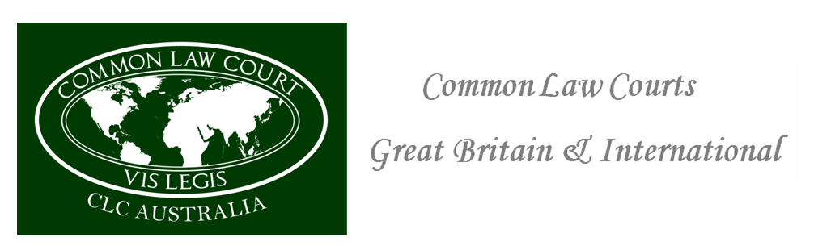
Corrie McKenzie Executive Director Fines and Enforcement Victoria in your private capacity as a living woman. 00th month 2022
Notice to the Agent is a notice to the principal Notice to the principal is a notice to the agent to the deputy secretary of fines and police you are deemed principal by the people of Victoria
As principal your responsible for agents which have failed to address a number of letters sent to your office by registered post therefore a recorded and proof of service can be provided. As your agent failed to reply or inform you to the first letters. A state of an accord of satisfaction has been reached therefore any further communication will be seen as stalking and demanding money with menaces without any lawful or legal justification. As a living woman will be held accountable and charged in your private capacity of misprision fraud and misprision of treason conspiracy to preverting the course of justice.
Should this practice continue, you will be summons as principal in your private capacity as a woman before Common-Law Jury of your peers where the Jury will make a decision as to whether you are guilty or not guilty of an indictable offence and a penalty may be fixed by the jury that has full lawful implications for you as principal on this demand for monies in relation to the unlawful and fictional fines.
Justice Department ABN number 32 790 228 959 evidence of Corporation
Autograph………………………….. Without prejudice

Po Box 291
Patterson Lakes VIC 3197
Australia
Po Box 291
Patterson Lakes VIC 3197
Australia
Po Box 291
Patterson Lakes VIC 3197
Australia

