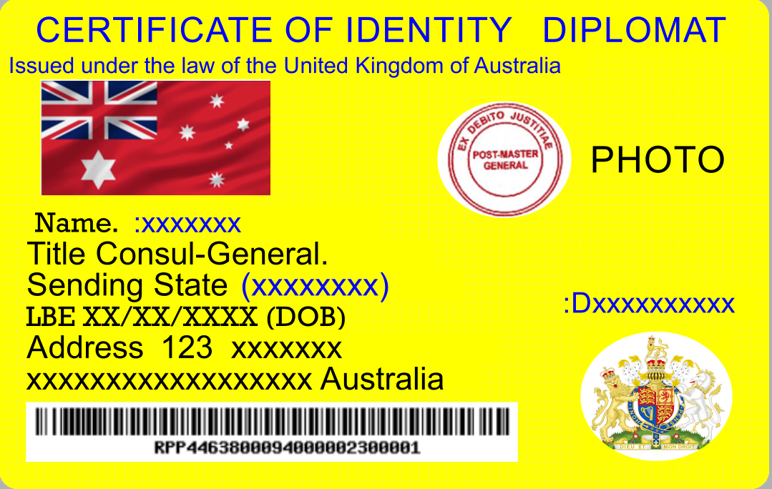

Summons an invitation to do Business

For the clerk of the court with the duty of filing this document in the correct jurisdiction under the bill of landing ACT and public vessels ACT.
With the knowledge of claim. :Hxxxx- mxxxxx. (xxxxxxxx) With the knowledge of fact. Knowledge of Charter vessel Law accept your invitation (summons) to do business on your vessel in dry dock at 000 x xxx xxxx xxxxxx on this day date 00/12/00 as the Principal for the deceased estate named (XXXXXX)
With the claim of knowledge of wrongdoing in the fictional case and the denial of human rights and false and fictional claims and language. And the right of claims of the colour of law by the corporations. Fact denial of common-law rights. With the Knowledge Queen Elizabeth11 unlawful removal from the Justice ACT of 1914 section 78B further denial of rights.
Knowledge of fact the Justice Department private Corporation ABN 32 790 22 959

Autographed by. : Xnnnn- xxxxxxxx As the Principal for deceased estate (XXXXX) at law.
Autograph……………………. Principal Without Prejudice

Explanation do not send this bit. Endorse the stamp (a normal postage stamp) on the back of document at the bottom right-hand corner with normal autograph should be at 45° example
For information on ID;s as above lundovenews@gmail.com

